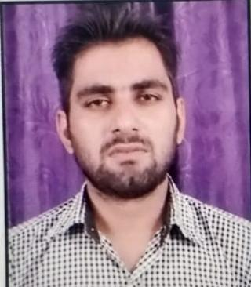

| Vikki Tyagi  Noida, u.p  **7017345391**  **vikkityagi1998@gmail.com** |  |
| --- | --- |
| SUMMARY *Seeking a suitable and rewarding career as a software coding, development, and testing professional with an esteemed Organization that would offer good advancement potential, challenges, and opportunities to zoom my career growth, contributing to the success of the Organization.* EXPERIENCE. software developer Ad Media Network llp From 08-2021 to 12-2021  **. Internship at gilman software private limited**  From 02-2022 to present EDUCATION ***Intermediate UP Board with*** 2015  *71.6 aggregate* *BCA from Sd college of management studies* 2015 - 2018 *65 aggregate* *MCA from Sd college of management studies*  2018 - 2021 *80.2 aggregate*PROJECTS *•* ***PROJECT-1:*** *CONTACT MANAGEMENT SYSTEM*  ***. PROJECT-2:***  *EVENT IRAD*  *Make an interactive form in event Irad through flutter which can automatically get the address of the user's current date and time, get mobile number*  *•* ***PROJECT-3:*** *FARMER PROBLEM SOLUTION* | SKILLS 1. python  2. java  3. javascript  4. Node js+Express  5. Flutter  6. Angularjs  7. Django (Read data from API and make graph)    HOBBIES:  •Playgame  •Time Management  •Like To Read And Learn  •Versatile person  •Keep Silent And Learn More  .  **Achievement**   1. ***c++ (05/2017 - 08/2017)*** 2. ***Java (08/2017-11/2017)*** 3. ***Certification of Excellence (2021)*** 4. ***Panda in python(11-2021 to 01/2022)*** |
|  |  |